EXPERIMENT 5
FOURIER SERIES ANALYSIS OF PERIODIC SIGNALS

OBJECTIVE:
i) To analyze Fourier series of continuous-time periodic signals and analyze their waveform characteristics.
(ii) To reconstruct periodic signals using Fourier series and verify the reconstructed waveform with the original signal.

MATLAB CODING :
clc; clear; close all;
%% 5(i) Analysis of Fourier Series Representation of Continuous-Time Periodic Signals
figure;
% Fourier Series Representation of a Periodic Signal
A = 1;
f0 = 1;
T = 1/f0;
t = linspace(0, 2*T, 2000);
% Half-wave rectified sinusoidal signal
x = A*sin(2*pi*f0*t);
x(x < 0) = 0;
N = 10;
a0 = (2/T)*trapz(t, x)/2;
an = zeros(1,N);
bn = zeros(1,N);
for k = 1:N
an(k) = (2/T)*trapz(t, x.*cos(2*pi*k*f0*t));
bn(k) = (2/T)*trapz(t, x.*sin(2*pi*k*f0*t));
end
xFS = a0*ones(size(t));
for k = 1:N
xFS = xFS + an(k)*cos(2*pi*k*f0*t) ...
+ bn(k)*sin(2*pi*k*f0*t);
end
plot(t,x,'k','LineWidth',1.2); hold on;
plot(t,xFS,'r--','LineWidth',1.2);
grid on;
xlabel('Time (s)'); ylabel('Amplitude');
title('Fourier Series Representation of a Periodic Signal');
legend('Original Signal','Fourier Series Reconstruction');

MATLAB CODING :
clc; clear; close all;
%% 5(iv) Verification of Fourier Series Reconstruction and Analysis of Signal
Characteristics
figure;
% Fourier Series Reconstruction and Error Analysis
f0 = 1;
T = 1/f0;
t = linspace(0,2*T,4000);
x = max(sin(2*pi*f0*t),0);
N = 10;
a0 = (2/T)*trapz(t(1:2000),x(1:2000));
an = zeros(1,N); bn = zeros(1,N);
tt = t(1:2000); xx = x(1:2000);
for k = 1:N
an(k) = (2/T)*trapz(tt,xx.*cos(2*pi*k*f0*tt));
bn(k) = (2/T)*trapz(tt,xx.*sin(2*pi*k*f0*tt));

end
xr = a0/2*ones(size(t));
for k = 1:N
xr = xr + an(k)*cos(2*pi*k*f0*t) + bn(k)*sin(2*pi*k*f0*t);
end
err = x-xr;
subplot(2,1,1);
plot(t,x,'k',t,xr,'r--','LineWidth',1.1);
grid on; xlabel('Time (s)'); ylabel('Amplitude');
title('Original and Reconstructed Signals');
legend('Original','Reconstructed');
subplot(2,1,2);
plot(t,err,'b'); grid on;
xlabel('Time (s)'); ylabel('Error');
title('Reconstruction Error');

OUTPUT :
To analyze Fourier series of continuous-time periodic signals and analyze their waveform characteristics.
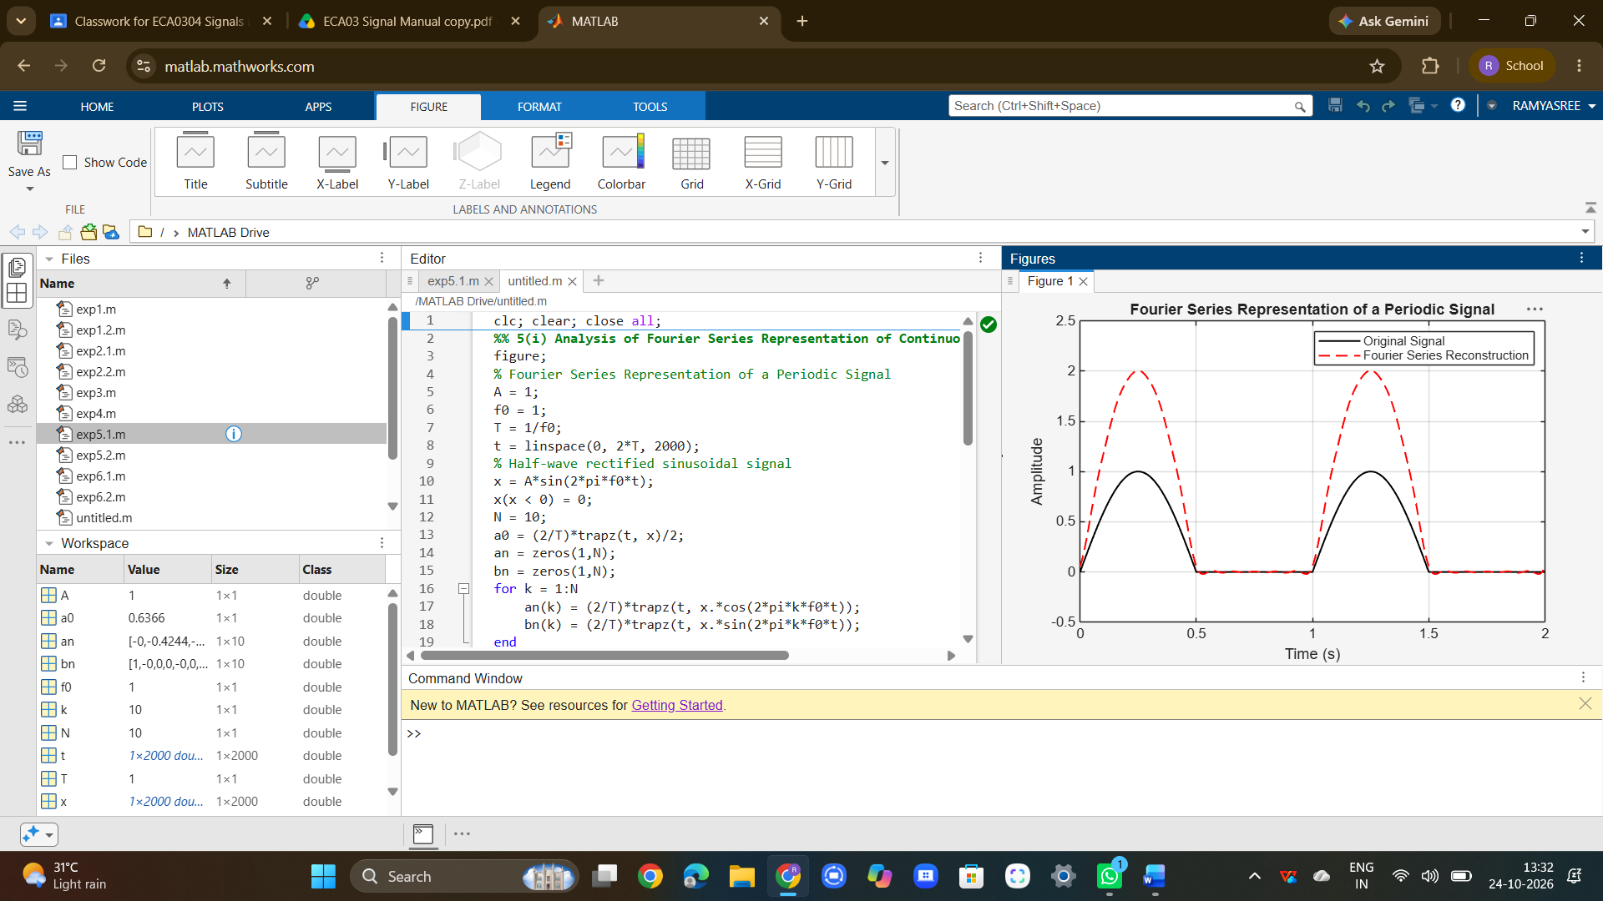
To reconstruct periodic signals using Fourier series and verify the reconstructed waveform with the original signal.
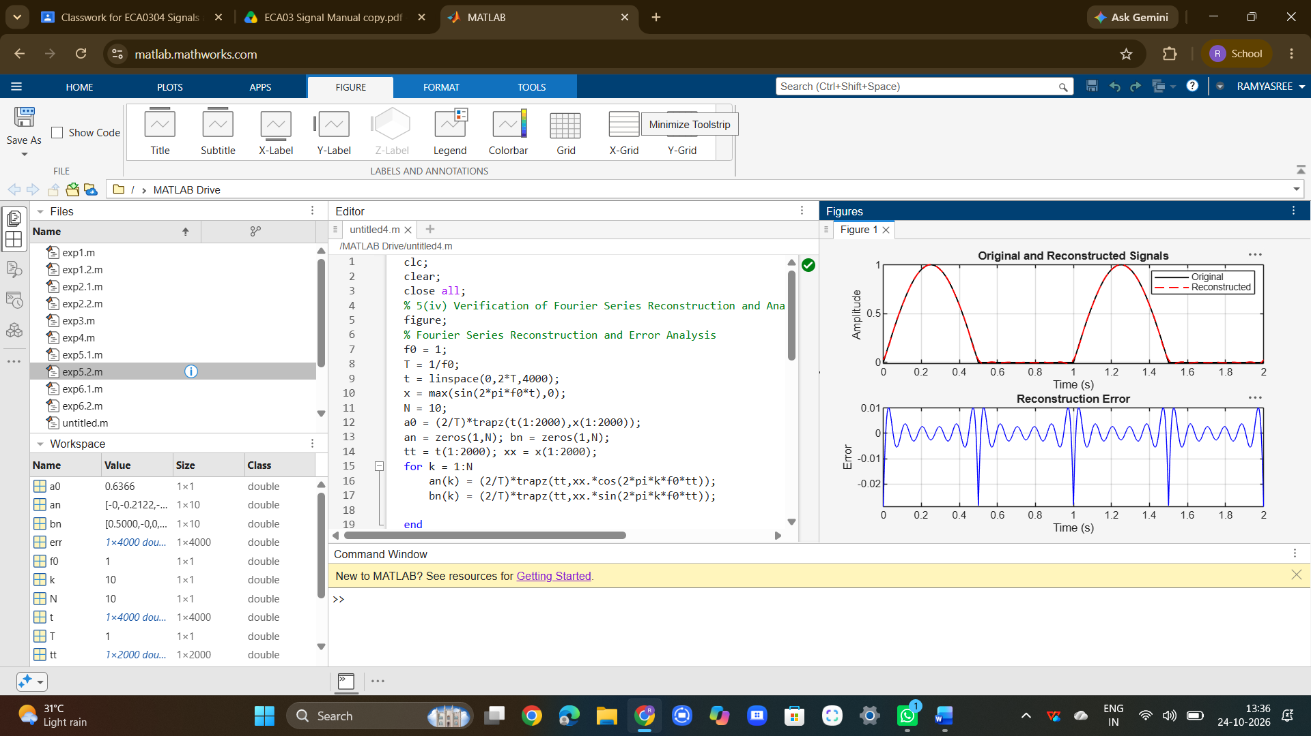
RESULT :
The Fourier series representation of periodic continuous-time signals was successfully analysed and the Fourier coefficients and harmonic components were determined. The amplitude and phase spectra were generated and their characteristics were studied. The periodic signal was reconstructed using Fourier series and the reconstructed waveform was verified with the original signal.

